**Bootstrap Basic & Advanced**

**Prajapati Pavan**

1. What are the advantages of Bootstrap?

* Easy to prevent repetitions among multiple projects.
* We can create responsive design with bootstrap very easily.
* Bootstrap contains lots of styling features that can be apply CSS properties by adding appropriate class.

1. What is a Bootstrap Container, and how does it work?

* Containers are the most basic layout element in Bootstrap.
* Containers are used to contain and center the content within them.
* Containers are used to give some padding to all sides.

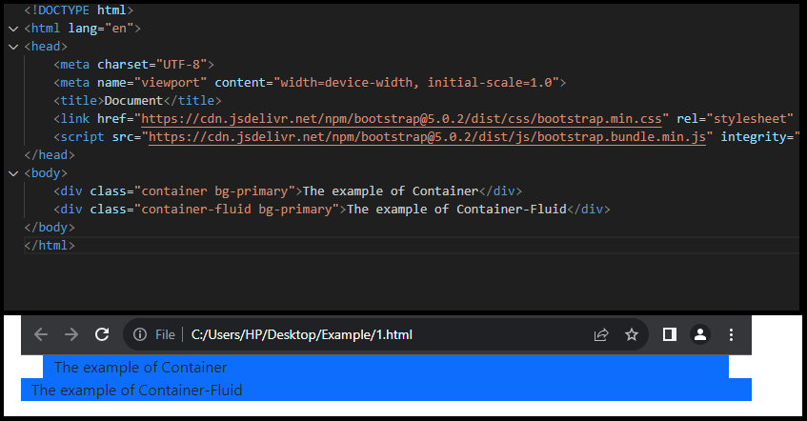

1. What are the default Bootstrap text settings?

* Bootstrap 4 uses a default font-size of 16px, and its line-height is 1.5.
* The default font-family is "Helvetica Neue", Helvetica, Arial, sans-serif.

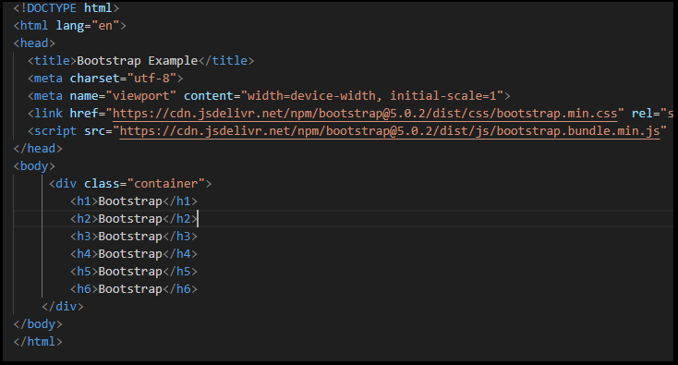

**Output**:

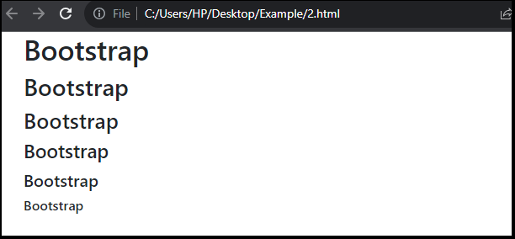

1. What do you know about the Bootstrap Grid System?

* Bootstrap’s grid system uses a series of containers, rows and columns to layout and align content.
* With the use of Bootstrap grid system we can make responsive design.
* Bootstrap’s grid system allows up to 12 columns across the page.

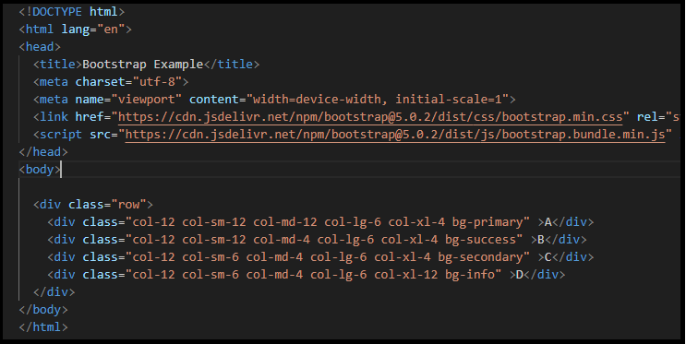

**Output:**

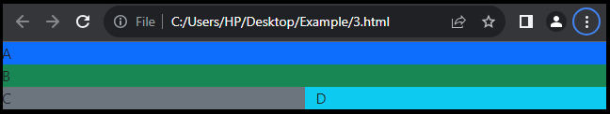

1. What is the difference between Bootstrap 4 and Bootstrap 5?

|  |  |  |
| --- | --- | --- |
| **Topics** | **Bootstrap 4** | **Bootstrap 5** |
| Color | It has limited colors | Extra colors added in bootstrap 5 |
| jQuery | It has jQuery | jQuery is removed from bootstrap 5 |
| Internet Explore | Supports both in IE 10 and 11 | It does not Support in IE 10 and 11 |
| Utility API | We cannot modify utilities | We modify utilities and also create our own utilities |
| Gutter | We use gutter with font size in px | Use .g* with font size in rem |
| icon | It does not have its own SVG icons | It have own SVG icons |
| Card deck | It has card deck class. | Card deck class remove |
| Navbar | We have inline-block property and we will get white dropdown | Inline-block property is removed and we will get black dropdown |
| Flexbox | Easier to implement vertical designs, and the columns and row can easily implemented | Advanced grid system is available. |
| Offcanvas | It does not support off canvas | It support off canvas |
| Grid system | It has 5 levels | It has 6 levels |

1. What is a Button Group, and what is the class for a basic Button Group?

* Button Groups in Bootstrap is a class of name “btn-group” which is used to create a series of buttons in groups vertically or horizontally.

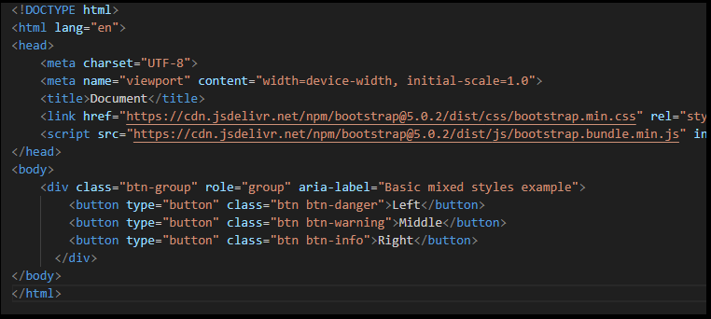

**Output:**

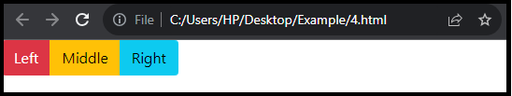

1. How can you use Bootstrap to make thumbnails?

* To create thumbnails we can use .img-thumbnail class.

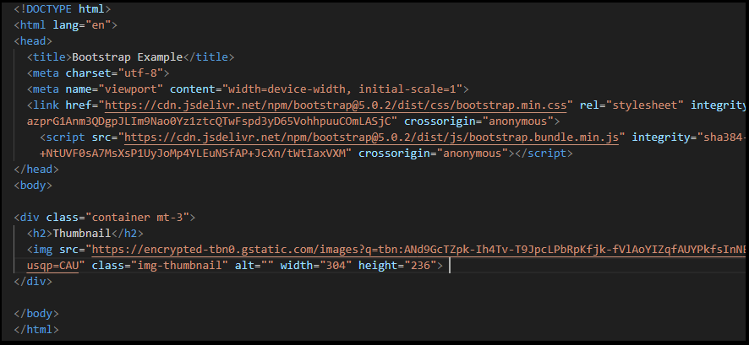

**Output:**

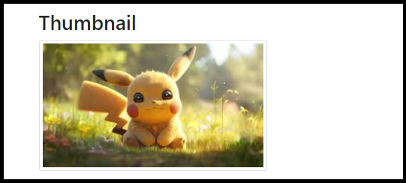

1. In Bootstrap 4, what is flexbox?

* The flexbox layout module, makes it easier to design flexible responsive layout structure without using float or positioning.

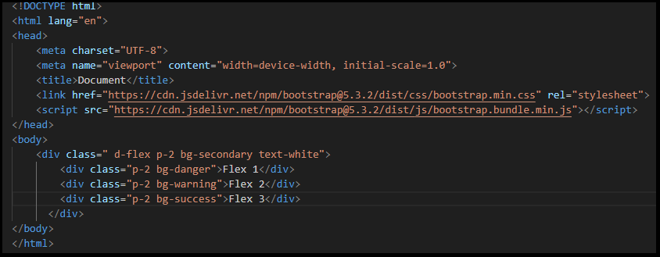

**Output:**

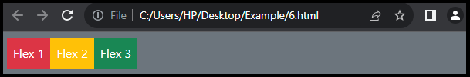

1. How can one create an alert in Bootstrap?

* With use of alert class we can create alert in bootstrap.

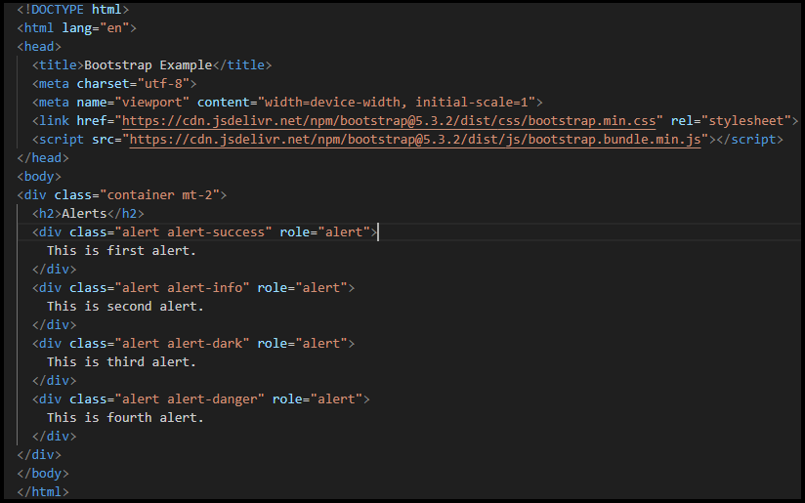

**Output:**

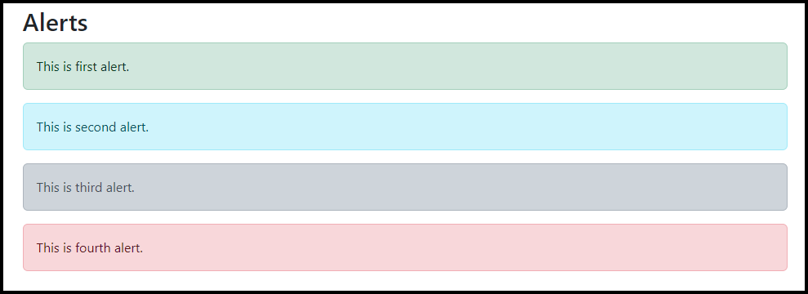

1. What is a bootstrap card and how would you create one?

* A Bootstrap card is a flexible and extensible content container.
* With the use of .card class we can create cards in bootstrap.

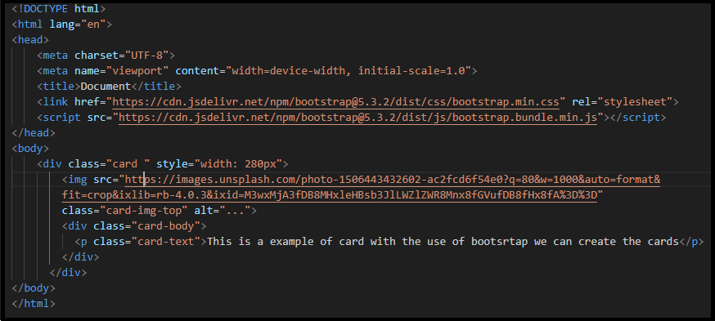

**Output:**

